East West University
Project Report
CSE 106: Discrete Mathematics
Department of Computer Science & Engineering

Submitted By:

- Arup Bhowmik Pritom
ID:2025-2-60-330
- Mahin Mahjabin
ID:2025-2-60-385
- Lakibul Hasan
ID: 2025-2-60-294

Submitted To:

Lecturer Ahmed Abdal Shafi Rasel
Department of Computer Science & Engineering

Date :17-12-2025

1.Description of the C Program
Code:
https://github.com/CodeWithPritom/CSE-106-Project.git
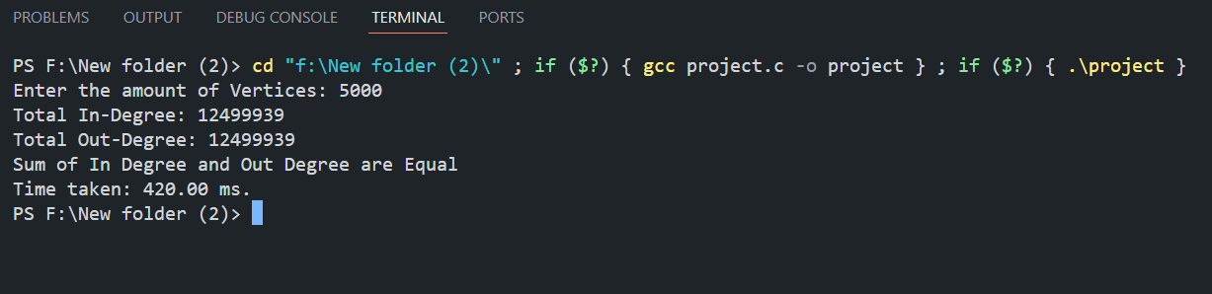
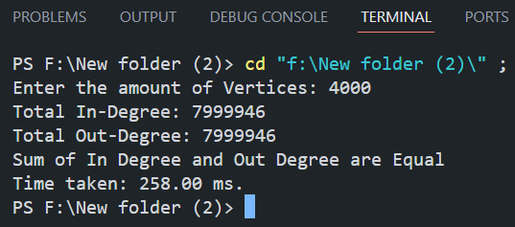
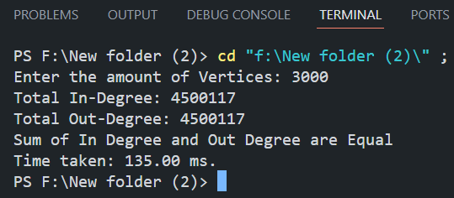
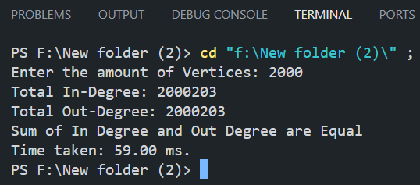
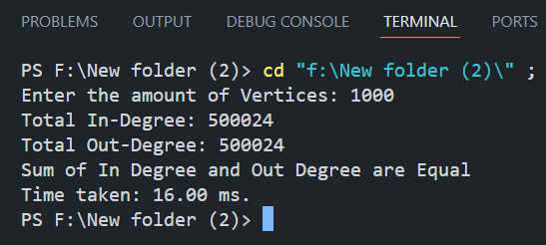
Output:

Here is the output of the program for different vertexes where n = 1000, 2000,3000,4000,5000. In every example the in degrees and the out degrees are equal. The given C program generates a random directed graph using an adjacency matrix representation. The number of vertices n is taken as input from the user. The adjacency matrix is an n × n matrix where an entry adj[i][j] = 1 represents a directed edge from vertex i to vertex j, and 0 represents no edge.
After generating the graph, the program computes the in-degree and out-degree of each vertex. The in-degree of a vertex is the number of edges coming into it, while the out-degree is the number of edges going out of it. Finally, the program calculates the sum of all in-degrees and sum of all out-degrees and verifies the fundamental property of directed graphs that these two sums are equal. The execution time required to calculate the degrees is measured using the clock() function.
2. Theoretical Time Complexity Determination
Theoretical time complexity is determined by analyzing the structure of the C code and counting the dominant operations as a function of the input size n.
- Graph generation:
The adjacency matrix is filled using two nested loops, each running from 0 to n − 1. Therefore, this step performs n × n operations, resulting in a time complexity of O(n²).
- In-degree and out-degree calculation:
The program again scans the entire adjacency matrix using two nested loops to check each entry. This step also takes O(n²) time.
- Summation of degrees:
A single loop runs over all vertices to compute the sum of in-degrees and out-degrees, which takes O(n) time.
Since O(n²) dominates O(n), the overall theoretical time complexity of the program is: O(n²)
3. Practical Time Complexity Determination
Computational time was measured for n = 1000 up to n = 5000. The raw execution time was recorded in milliseconds (ms) using the clock() function and then converted into seconds for standardized plotting in Microsoft Excel.
n=1000, t=16ms
n=2000, t=59ms
n=3000, t=135ms
n=4000, t=258ms
n=5000, t=420ms
The data points were plotted, and a second-order polynomial trendline was fitted to the graph. The resulting trendline equation is:
y = 0.00000002n² + 0.00002n − 0.02
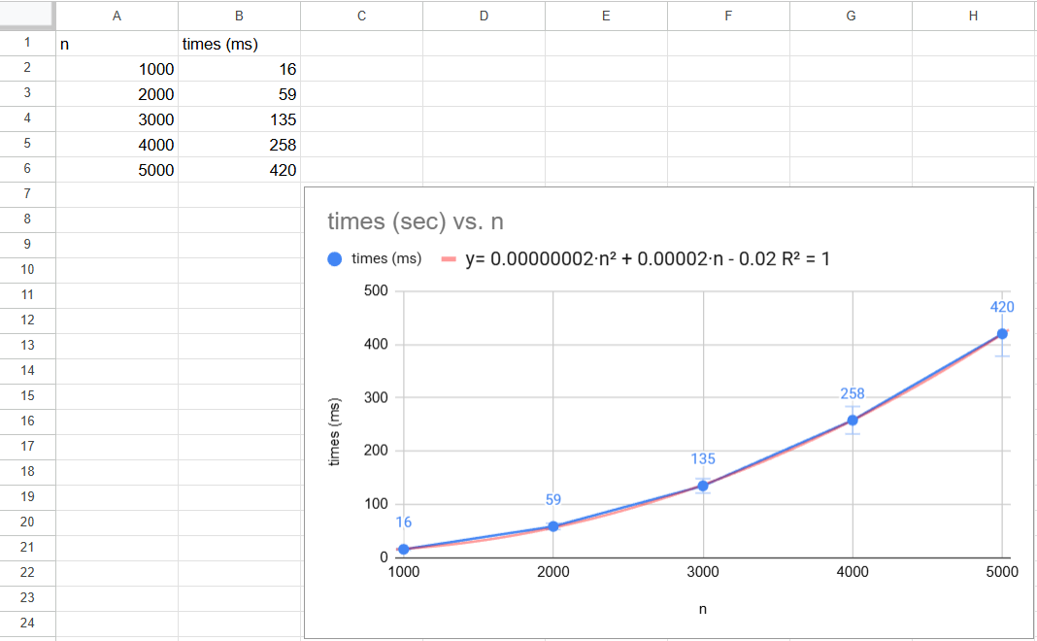
Here,
- x represents the number of vertices, and
- y represents the execution time.
In this equation, the n² term is the highest-degree component. As the number of vertices (n) grows larger, the n² term dominates the execution time, while the linear and constant terms become negligible. This experimentally confirms that the practical complexity is O(n²).

4. Comparison of Theoretical and Practical Time Complexities
The theoretical analysis of the C code predicts a time complexity of O(n²) due to the nested loop structure required for matrix traversal. The experimental analysis, supported by the polynomial trendline and runtime data, also shows a quadratic growth pattern (y $∝$ n²).
The results are perfectly consistent:
- Theoretical Complexity: O(n²)
- Practical Complexity: O(n²)
Furthermore, the program consistently demonstrates that the sum of in-degrees is equal to the sum of out-degrees ( ∑d_{in} = ∑d_{out} ), verifying the Handshaking Lemma for directed graphs.

